AI ASSISTED CODING
ASSIGNMENT 6.1
Name:v jahnavi reddy
Ha;ll tic: 2303a51839
Batch 27
Task Description #1: AI-Based Code Completion for Loops
Prompt Used
“Generate Python code to print all even numbers between 1 and N using a loop.”
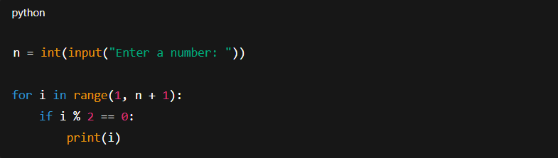
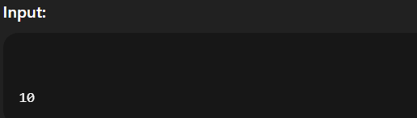
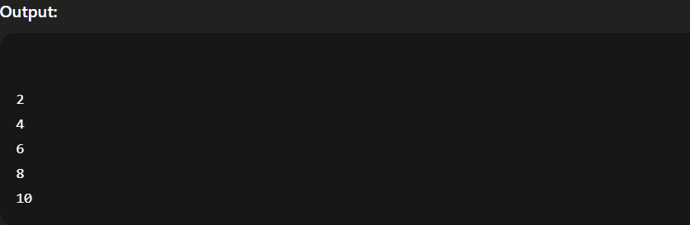
Task Description #2: AI-Based Code Completion for Loop with Conditionals
Prompt Used
“Generate Python code to count how many numbers in a list are even and odd.”
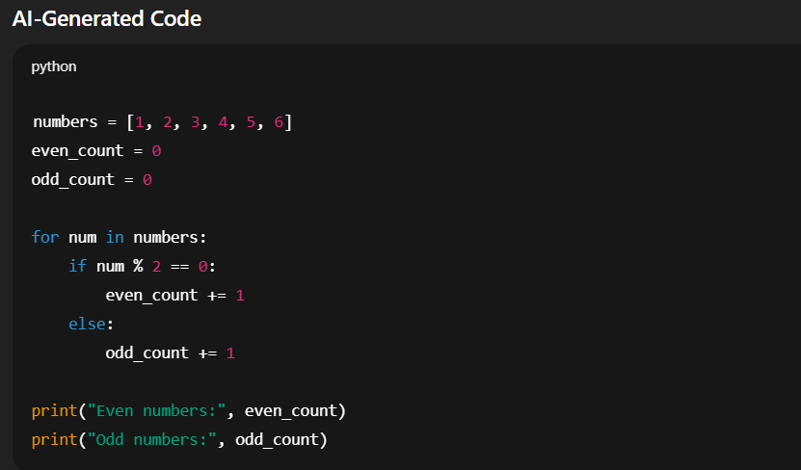
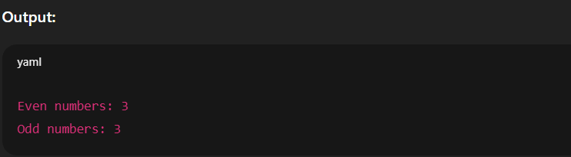
Task Description #3: AI-Based Code Completion for Class Attributes Validation
Prompt Used
“Generate a Python class User that validates age and email using conditional statements.”
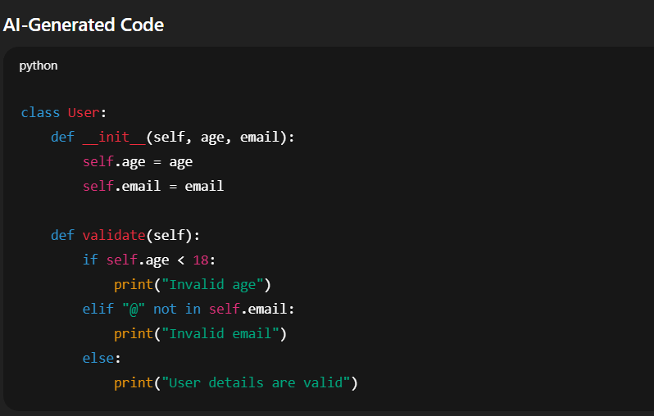
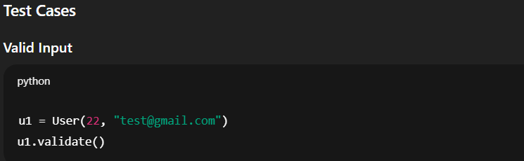

Task Description #4: AI-Based Code Completion for Classes
Prompt Used
“Generate a Python class Student with attributes (name, roll number, marks) and methods to calculate total and average marks.”
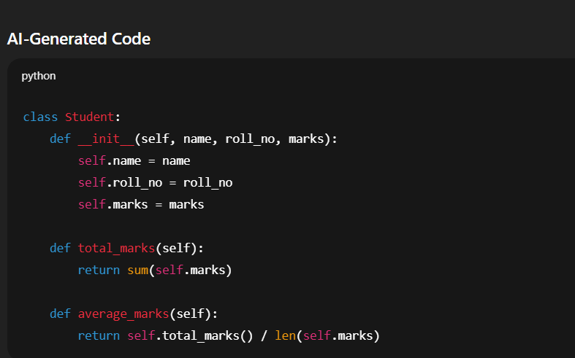
Task Description #5: AI-Assisted Code Completion Review
Prompt Used
“Generate a Python program for a simple bank account system using class, loops, and conditional statements.”
